**The laboratory work 2**

**Study of equivalent transformations of structural schemes**

**Main connections of structural schemes**

The main compounds of structural schemes include the following:  
1) The connection of the links (Figure 3.1, a) is called sequential - the output value of one link is the input value of the other.  
2) The connection of the links (Figure 3.1, b) is called parallel if the inputs of all links are supplied with the same value, and the output values ​​are summed.  
3) Parallel-counter connection (Figure 3.1 c) is called feedback (OS). The adder closes the loop or loop feedback, if the signal is fed to the adder with a negative sign, then there is a negative OS, otherwise a positive OS. In the future, this system will be called a closed system.

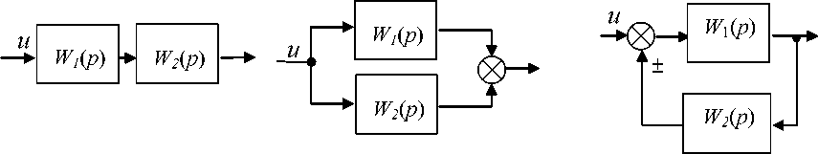

a) sequential; b) parallel; c) feedback.  
Figure 3.1 - The main connections of the links

**3.2 Basic transformations of structural diagrams**  
  
The block diagram of control systems can contain a large number of links, and their connection can be arbitrary. A complex connection of links can be converted into a simpler one, while maintaining the dynamic characteristics of the system based on the principle of superposition: the sum of the reactions of a link (or system) to individual influences is equal to the reaction of a link to the sum of the same effects [2, 3]. This provides mathematical expressions for the equivalent transfer function:

|  |  |
| --- | --- |
| - figure 3.1 а; | (3.1) |
| - figure 3.1 б; | (3.2) |
|  |  |
| - figure 3.1 в, | (3.3) |

if negative OS, then the sign in the denominator is “plus”, otherwise - “minus”. Formulas (3.1-3.3) underlie the existing rules for transforming structural schemes (table 3.1).

Table 3.1 - Rules for the transformation of structural schemes

|  |  |  |
| --- | --- | --- |
| № | Initial scheme | Equivalent scheme |
| Two blocks in series | | |
| 1 |  |  |
| Two blocks connected in parallel | | |
| 2 |  |  |
| Feedback connection | | |
| 3 |  |  |
| Adder downstream | | |
| 4 |  |  |
| Adder versus signal travel | | |
| 5 |  |  |
| Node transfer against signal travel | | |
| 6 |  |  |
| Node downstream | | |
| 7 |  |  |

3.3 the order of the laboratory work №3  
  
1. Given are the schemes of the initial systems (table 3.2 and 3.3). Using the CST or MATLAB Simulink package commands, obtain transient characteristics.  
  
Table 3.2 - Structural diagrams of the source systems

|  |  |  |  |
| --- | --- | --- | --- |
| Variant | Structural scheme | Variant | Structural scheme |
| 0 |  | 5 |  |
| 1 |  | 6 |  |
| 2 |  | 7 |  |
| 3 |  | 8 |  |
| 4 |  | 9 |  |

Table 3.3 – Initial data

|  |  |  |  |  |  |  |
| --- | --- | --- | --- | --- | --- | --- |
| W1 | W2 | W3 | W4 | W5 | W6 | W7 |
|  |  |  |  |  |  |  |

1. . Get the expressions for the equivalent transfer functions and build the circuit (Figure 3.2).



Figure 3.2 - Equivalent circuit

3. Remove the transient characteristics of equivalent circuits, which should coincide with the transients obtained in paragraph 1.

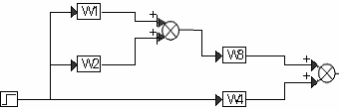3.4 Methodical example  
Let a block diagram be given (Figure 3.3) with transfer functions from Table 3.3.

Figure 3.3 – Structural scheme of the initial system

Based on the rules for transforming structural schemes, we obtain the transfer function of the equivalent system:

Figures 3.4 and 3.5 show the results obtained in MATLAB Simulink in the form of identical transition characteristics of the original and equivalent systems.  
  
Figure 3.4 - the results of the simulation of the source system

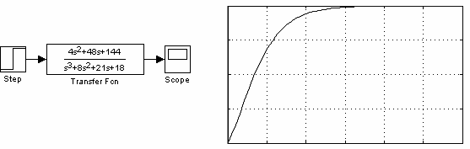

*y*(*t*)

Figure 3.5 - Simulation results of equivalent system 3.5